PROJECT REPORT
Streamlining IT Procurement: Automating Standard Laptop Orders with Flow Designer
Platform: ServiceNow (Flow Designer)
Submitted by : Muthu Eswari Aruna V
Muthu Priya A
Muthu Sandhiya E
Manisha B
Jenisha J
Department : Computer Science
College : Government Arts and Science College For Women, Sathankulam.
Academic Year : 2024 - 2026
CONTENTS
1. Introduction
1.1 Project Overview
1.2 Purpose
2. Ideation Phase
2.1 Problem Statement
2.2 Empathy Map Canvas
2.3 Brainstorming
3. Requirement Analysis
3.1 Customer Journey Map
3.2 Solution Requirement
3.3 Data Flow Diagram
3.4 Technology Stack
4. Project Design
4.1 Problem Solution Fit
4.2 Proposed Solution
4.3 Solution Architecture
5. Project Planning & Scheduling
5.1 Project Planning
6. Functional and Performance Testing
6.1 Performance Testing
7. Results
7.1 Output Screenshots
8. Advantages & Disadvantages
9. Conclusion
10. Future Scope
11. Appendix
1. INTRODUCTION
1.1 Project Overview
This project automates the ordering and configuration of standard laptops in an IT procurement process using the Flow Designer of ServiceNow. In the existing process, a request for a standard laptop must be followed by a manual configuration task, which is often missed or delayed. The project builds a flow that is triggered from the Service Catalog. Once the service request is approved, the flow automatically creates a Catalog Task with the short description "Laptop need to Configured" and assigns it to the Hardware group.
The flow is then attached to the "Standard Laptop" catalog item through the Process Engine, so every new order runs the automation without manual intervention.
1.2 Purpose
The purpose of this project is to reduce delays and manual overhead in standard laptop procurement. The project aims to:
- Create a seamless experience for users requesting standard laptops by ensuring timely configuration.
- Reduce manual intervention and potential errors in the procurement process.
- Improve resource utilisation within the IT department by optimising task allocation.
- Enhance overall efficiency and productivity in IT procurement operations.
2. IDEATION PHASE
The current IT procurement process lacks efficiency and automation, resulting in delays and manual overhead, particularly in handling standard laptop orders. Requests for standard laptops often require configuration, but this step is prone to oversight or delay, leading to frustration among users and inefficient resource allocation within the IT department.
User Story: As a member of the IT procurement team, I want a streamlined process for ordering standard laptops so that tasks are automatically generated and assigned to the hardware team for configuration. This will ensure that laptops are promptly configured upon arrival, reducing user wait times and minimising manual intervention.

2.2 Empathy Map Canvas
Quadrant | Details
Says | "My laptop request is taking too long."  "Has the laptop been configured yet?"
Thinks | Manual follow-ups waste time.  The configuration step may be forgotten.
Does | Raises a request in the Service Catalog.  Follows up repeatedly with IT and the Hardware team.
Feels | Frustrated by delays and lack of visibility.  Relieved when tasks are assigned automatically.
Pain Points | Missed or delayed configuration tasks, manual effort, unclear ownership.
Gains | Automatic task creation, faster laptop delivery, less manual work for the IT team.

2.3 Brainstorming
The team discussed several ways to remove the manual step in laptop configuration:
- Manually reminding the Hardware team by e-mail or chat – rejected, still manual and error-prone.
- Creating a business rule with scripting – possible, but harder to maintain for non-developers.
- Using Flow Designer with a Service Catalog trigger – selected, because it is a low-code, easy to maintain and easy to extend approach.
Final idea: trigger a flow on the Service Catalog request, create a Catalog Task after approval, and assign it automatically to the Hardware group.

3. REQUIREMENT ANALYSIS
3.1 Customer Journey Map
Stage | User Action | System Response | Experience
Request | Opens Service Catalog > Hardware > Standard Laptop and clicks Order Now | Request and Requested Item are created | Simple and quick
Approval | Approver opens the request and approves it | Approval status changes to Approved | Clear
Automation | No action needed | Flow creates a Catalog Task and assigns it to Hardware | Effortless
Configuration | Hardware team sees the task "Laptop need to Configured" | Task is tracked against the Requested Item | Timely
Delivery | Receives the configured laptop | Request is closed | Satisfied

3.2 Solution Requirement
Functional requirements:
- Service Catalog item "Standard Laptop" available under the Hardware category.
- A flow named "Standard laptop task" with a Service Catalog trigger.
- An action to create a Catalog Task linked to the Requested Item.
- Task fields: short description "Laptop need to Configured", assignment group "Hardware", approval "Approved".
- Flow attached to the catalog item through the Process Engine.
Non-functional requirements: reliability, easy maintenance, role-based access and traceability of every request.

3.3 Data Flow Diagram
Step | From | Process | To
1 | User | Orders Standard Laptop from Service Catalog | Request / Requested Item
2 | Approver | Approves the request | Approval record
3 | Flow Designer | Service Catalog trigger fires after approval | Create Catalog Task action
4 | Create Catalog Task | Creates task with short description and Hardware group | Catalog Task table
5 | Hardware team | Configures the laptop and updates the task | Requested Item

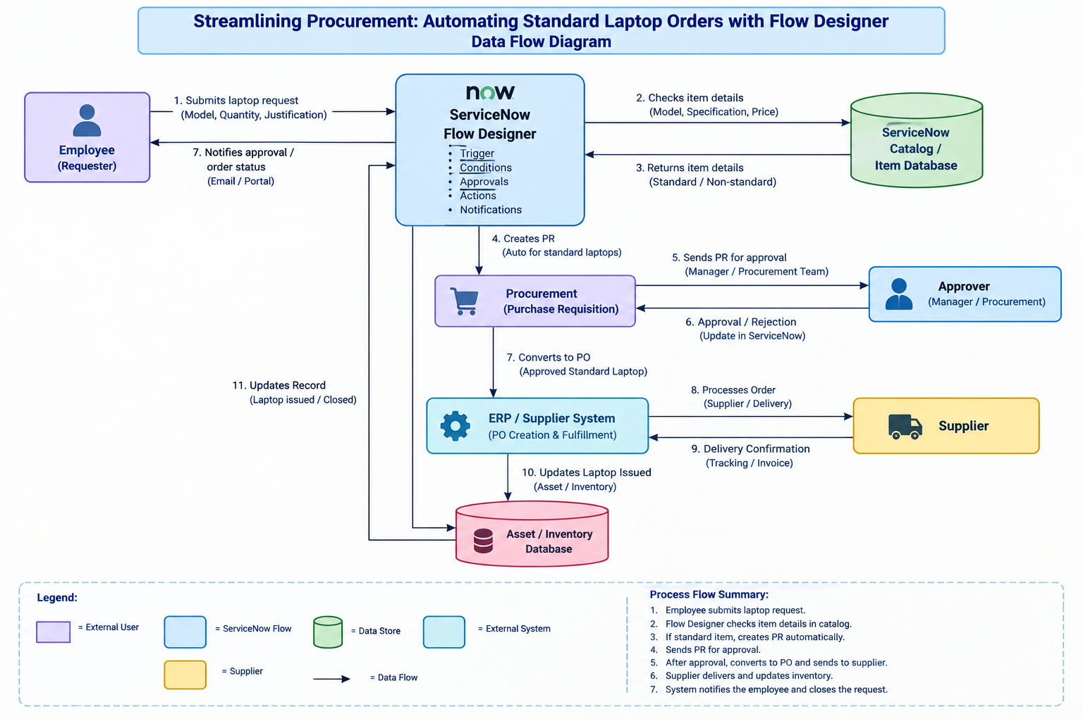

3.4 Technology Stack
Component | Technology
Platform | ServiceNow (Personal Developer Instance)
Automation tool | Flow Designer (Process Automation)
Trigger | Service Catalog
Action | Create Catalog Task
Modules used | Service Catalog, Maintain Items, Requested Items, Catalog Tasks
Access | Web browser

4. PROJECT DESIGN
4.1 Problem Solution Fit
The problem is a delayed and manual laptop configuration step. The solution is an automated flow that creates and assigns the configuration task as soon as the request is approved. This fits the need of the IT procurement team (less manual work) and the end user (faster laptop readiness).
4.2 Proposed Solution
A flow named "Standard laptop task" is created in Flow Designer with the Service Catalog trigger. The Create Catalog Task action uses the Requested Item record and fills in the short description, description, assignment group (Hardware) and approval (Approved). The flow is activated and mapped to the Standard Laptop catalog item under the Process Engine, replacing other automations.
4.3 Solution Architecture
Layer | Description
User layer | Employee orders the Standard Laptop through the Service Catalog
Approval layer | Approver approves the request from the Approvers section
Automation layer | Flow Designer: Service Catalog trigger > Create Catalog Task action
Data layer | Request, Requested Item and Catalog Task tables
Fulfilment layer | Hardware assignment group configures the laptop

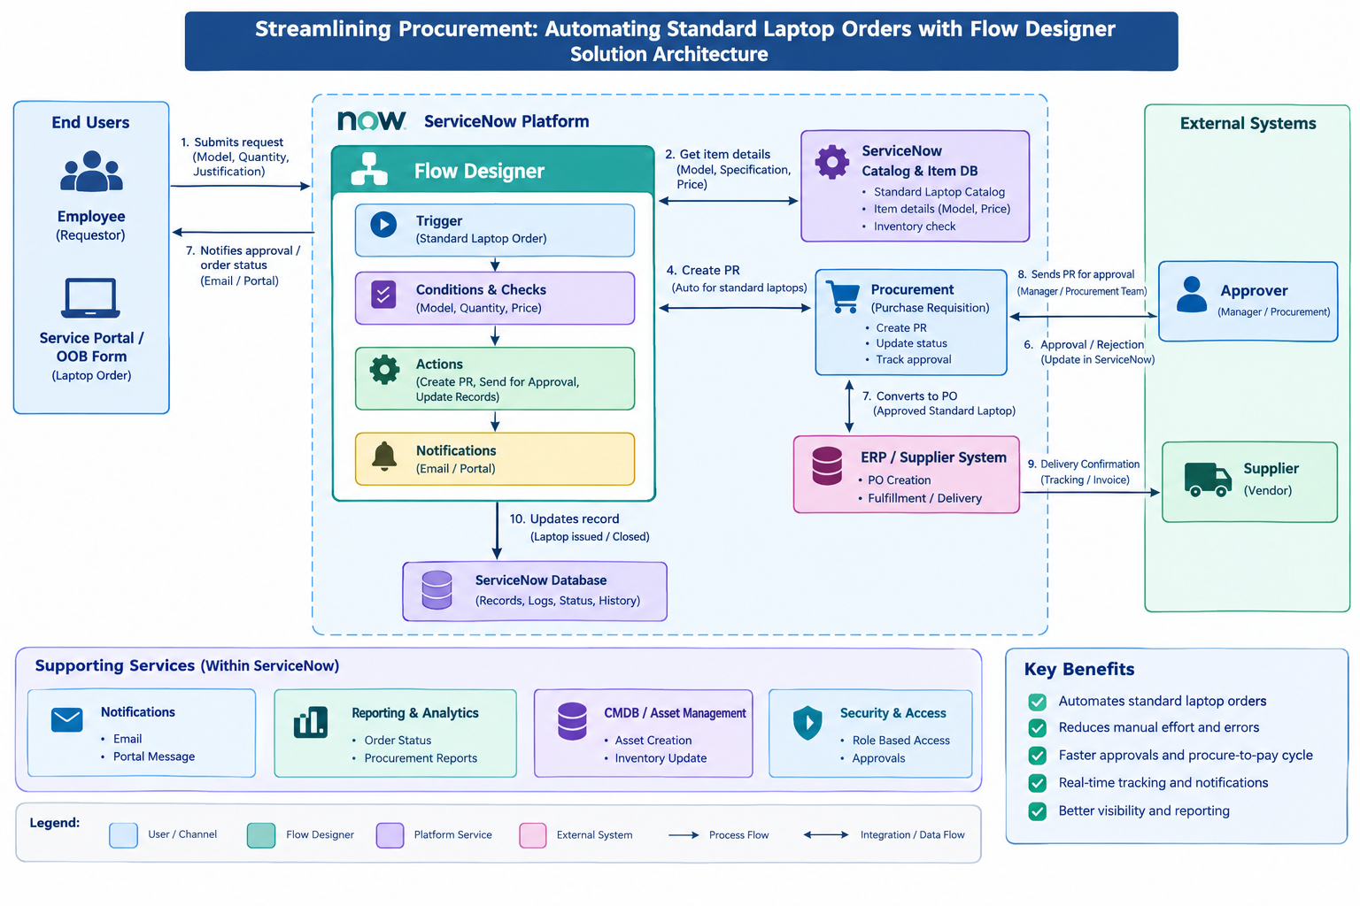
5. PROJECT PLANNING & SCHEDULING
5.1 Project Planning
Milestone | Activity | Status
Milestone 1: Flow | Create a flow with Service Catalog trigger and Create Catalog Task action; save and activate | Completed
Milestone 2: Flow assignment | Attach the flow to the Standard Laptop item using the Process Engine | Completed
Milestone 3: Service Catalog | Place the order, approve it and verify the Catalog Task | Completed

6. FUNCTIONAL AND PERFORMANCE TESTING
6.1 Performance Testing
Test Case | Expected Result | Result
Order Standard Laptop | Request and Requested Item are created | Passed
Approve the request | Approval status becomes Approved | Passed
Flow execution | Flow runs automatically after approval | Passed
Catalog Task creation | Task created with short description "Laptop need to Configured" | Passed
Task assignment | Assignment group is Hardware | Passed

7. RESULTS
7.1 Output Screenshots
Milestone 1 – Creating the flow (Standard laptop task)
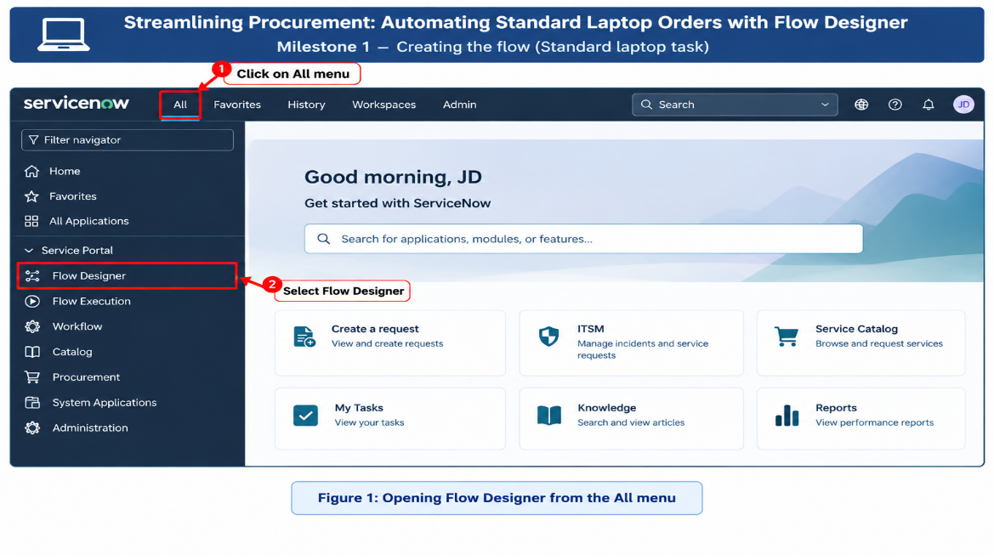
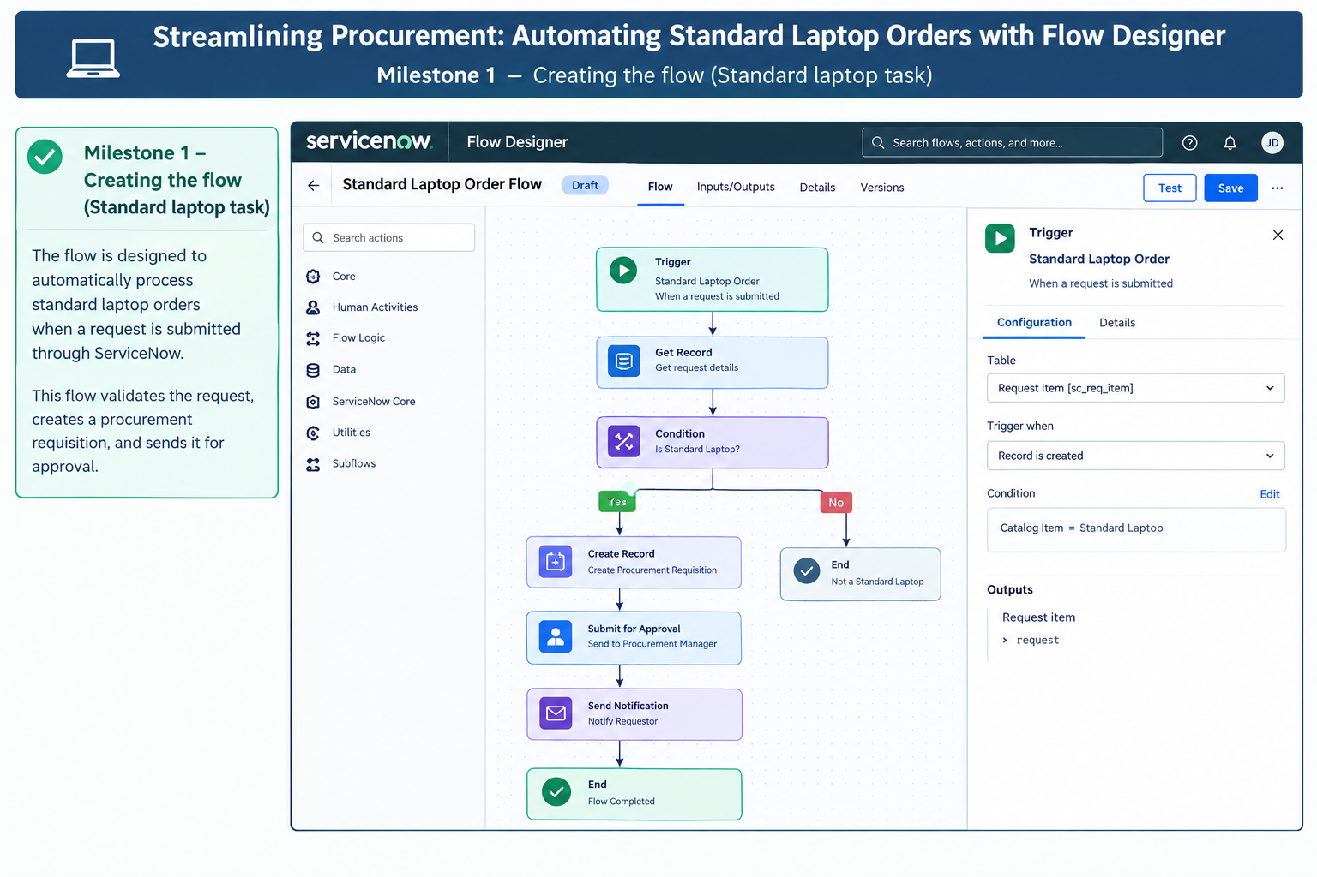Figure 1: Opening Flow Designer from the All menu

Figure 2: Flow Designer home page (New > Flow)
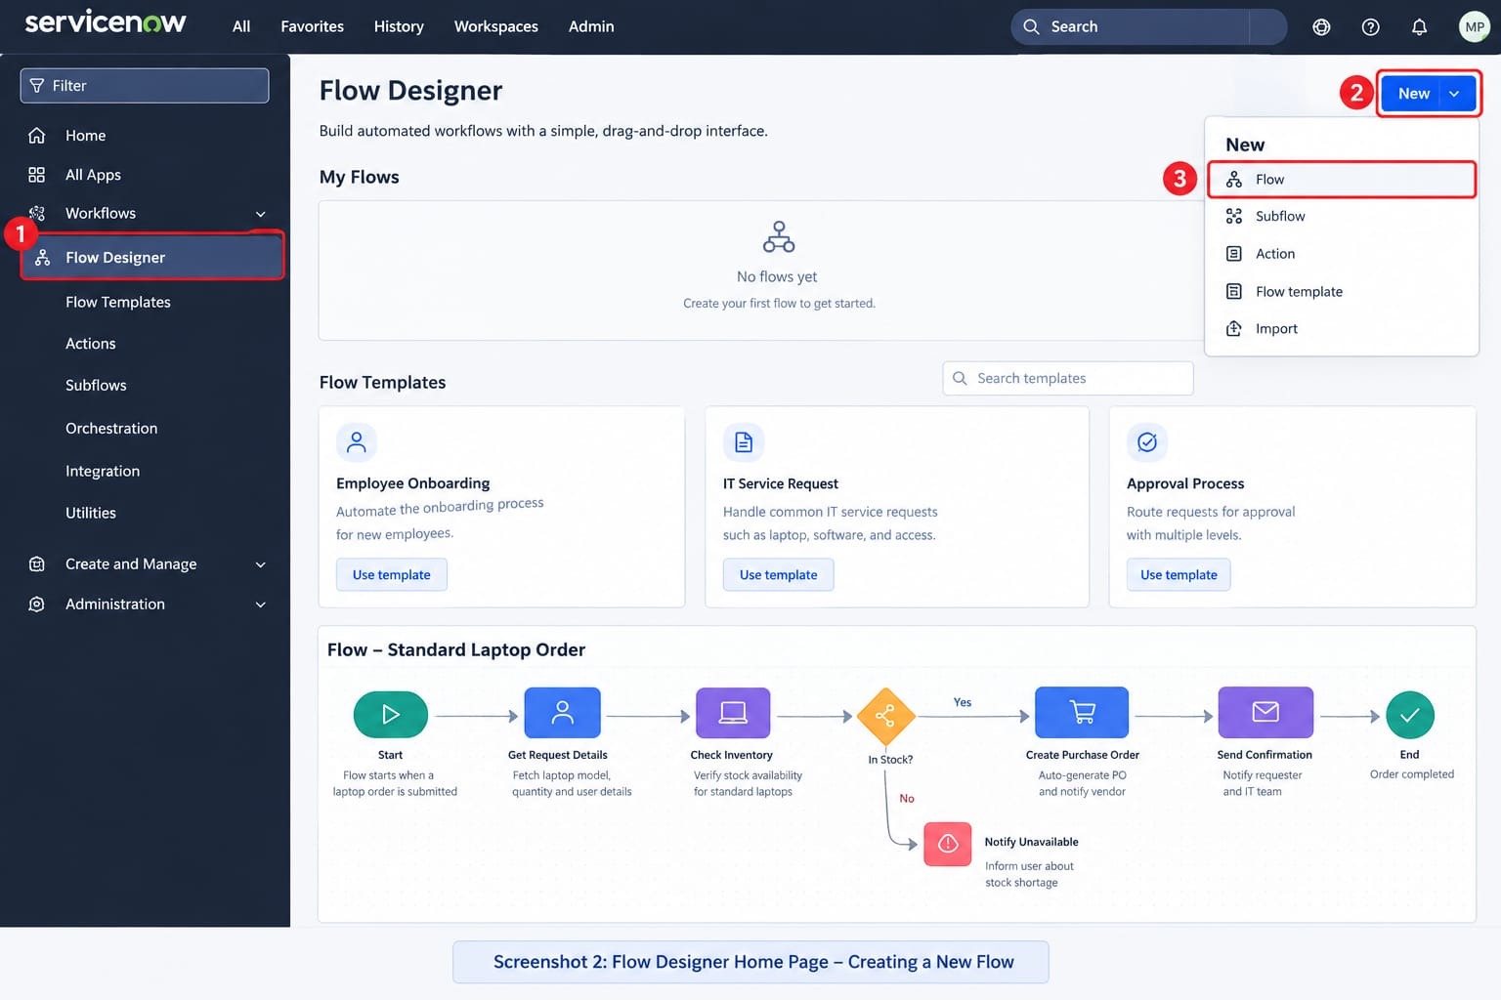

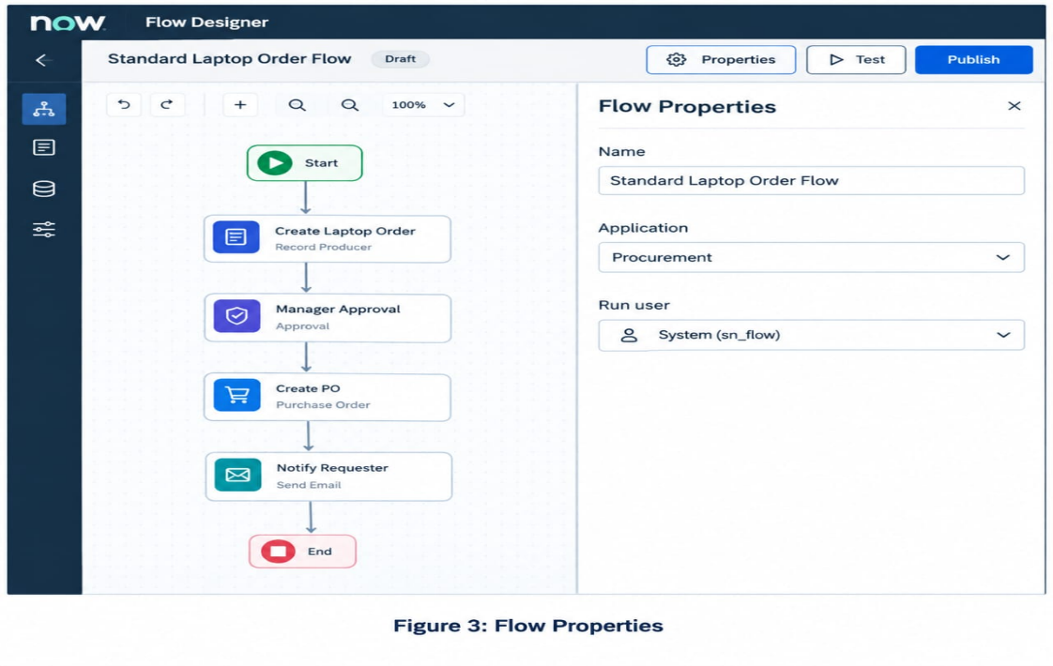
Figure 3: Flow properties (name, application, run user)
Figure 4: Adding the Service Catalog trigger
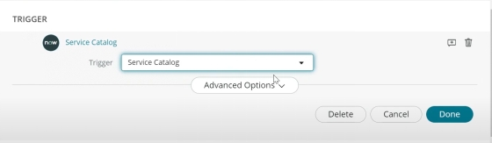
Figure 5: Trigger configured
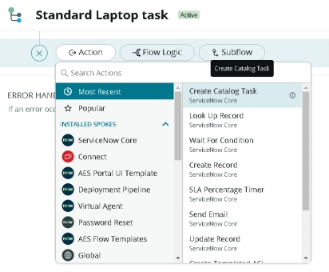
Figure 6: Create Catalog Task action
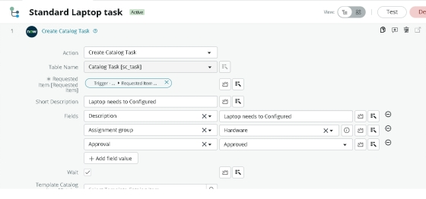
Figure 7: Action field values
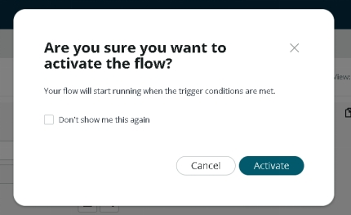
Figure 8: Activating the flow
Milestone 2 – Flow assignment to the Standard Laptop catalog item
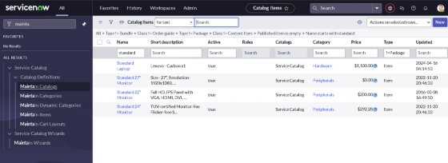
Figure 9: Maintain Items
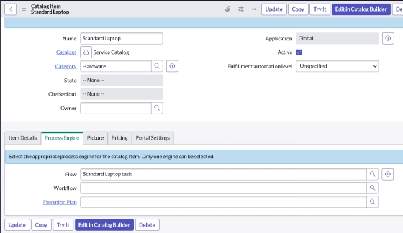
Figure 10: Flow added under Process Engine
Milestone 3 – Ordering, approval and Catalog Task
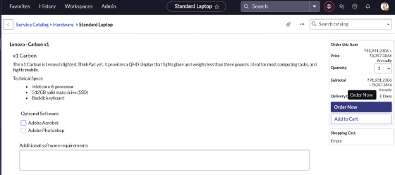
Figure 11: Standard Laptop in Service Catalog
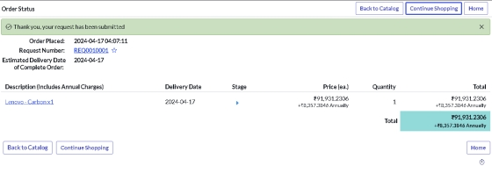
Figure 12: Order status
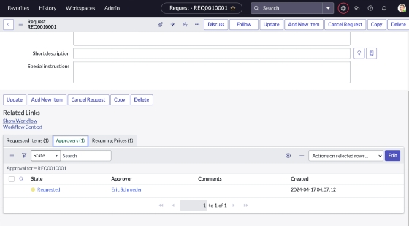
Figure 13: Approvers section of the request
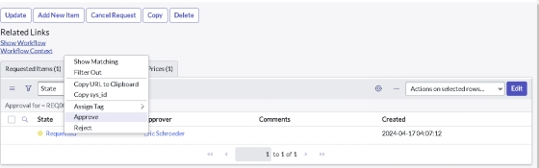
Figure 14: Approving the record
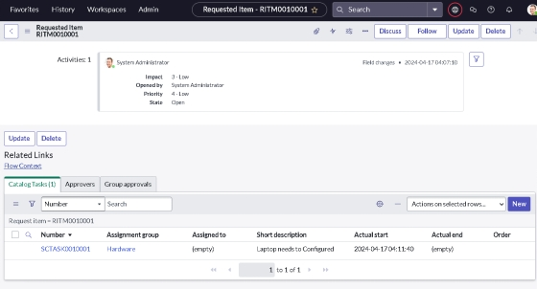
Figure 15: Requested Item record
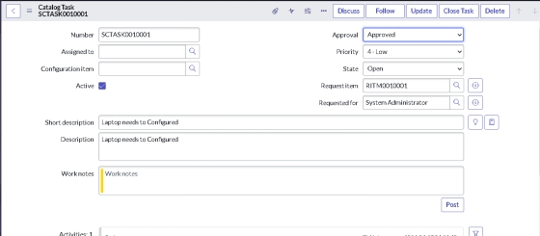
Figure 16: Catalog Task with short description and Hardware group
8. ADVANTAGES & DISADVANTAGES
Advantages
- Catalog Tasks are created automatically, so no configuration step is missed.
- Reduces user waiting time and manual follow-ups.
- Low-code solution that is easy to modify and maintain.
- Better use of Hardware team resources through automatic assignment.
- Every request is traceable from order to task.
Disadvantages
- Depends on the ServiceNow platform and proper licensing.
- Works only for the Standard Laptop item until extended to other items.
- Incorrect flow configuration can stop task creation, so testing is needed after every change.
9. CONCLUSION
By automating the standard laptop procurement process with ServiceNow's Flow Designer, the project effectively addresses inefficiencies and reduces manual overhead. This streamlined workflow ensures timely configuration of laptops, minimises user wait times, and enhances overall productivity within the IT department. The implementation of this automated solution not only optimises resource allocation but also significantly improves the user experience by providing a seamless and efficient procurement process.
10. FUTURE SCOPE
- Extend the flow to other catalog items such as laptops of other models, monitors and mobile devices.
- Add e-mail or notification actions to alert the requester when configuration is complete.
- Add conditions for different approval levels based on cost or department.
- Build dashboards and reports on procurement turnaround time.
- Integrate with asset management to update inventory automatically.
11. APPENDIX
Source Code: Not applicable (no-code / low-code flow built in Flow Designer).
Dataset Link: Not applicable.
GitHub & Project Demo Link: [Add your link here]

